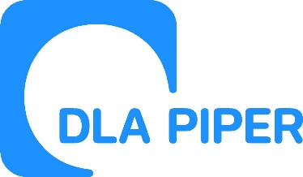
Bionow Annual Awards 2021
Application Form – Bionow Export Award
Applications are invited from and on behalf of companies or organisations who are trading their products, services and expertise overseas and believe fulfil the award criteria below.
The Bionow Export Award will be presented to a company that satisfies the following conditions:
- Falls within the definition “the use of innovative approaches to develop biomedical services, equipment or products particularly those which serve the needs of human healthcare”.
- Can clearly demonstrate export successes and have a significant proportion of their sales in international markets.
- Have the ability to demonstrate a strategy employed over a period time and can demonstrate pioneering activities that have led to growth in sales.
The competition will be judged on:
- Current and future export strategy and development;
- Growth in export sales;
- Creativity and innovation that has led to success;
- Barriers that the company has encountered and overcome.
Please complete the application form below, ensuring that all fields are completed and any additional documentation that is required to support the application is attached.
Applications should be sent to awards@bionow.co.uk ensuring that the subject line of your email clearly indicates the award category that you are applying for.
Closing date: Midday on Thursday 23rd December 2021
Please note that there will be no extension given to this deadline.

All information provided will be treated in confidence and only distributed to the judging panel for use in this competition. The judging panel will consist of one invited representative from each of the award sponsor organisations plus Bionow. The decision of the panel will be by majority and is final.

Applicant Details
Name
Title
Position
Company/Institution
Address

Postcode
Telephone
Email

Export Details
Date company started to export
Product / Service exported
Turnover from export sales
Percentage of sales from export
Growth in export sales over recent years
Barriers that the company has overcome
Export details
(Max 50 words)
If shortlisted this profile will feature within the Awards brochure

In less than 400 words, please describe why the company fulfils the award criteria and should win this award. Each application MUST be supported with an export strategy / business plan or other appropriate documentation which addresses the award criteria above and allows the success with exporting and the current and future strategy to be determined by the judging panel.

