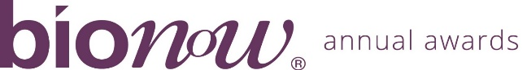

Bionow Annual Awards 2021 - Application Form
Response to the COVID-19 Pandemic Award
Applications are invited from and on behalf of companies, social enterprises, research or healthcare organisations, universities or other bodies that have a project which they believe fulfil the award criteria.
The Bionow Response to the COVID-19 Pandemic Award will be presented to reward research or innovation that has the potential to deliver a significant contribution to the understanding of, and response to, the COVID-19 pandemic and its impacts. This can include but is not limited to:

- Services or new business approaches;
- Projects, services or products;
- Diagnostics or treatments aimed at directly combating the disease;
- Initiatives which support the manufacture, distribution and/or wide scale adoption of an intervention with significant potential.
The competition will be judged on:
- Impact of the approach on the COVID-19 pandemic;
- Quality of the project, R&D initiative, product, service or approach;
- Degree of innovation;
- Route to market/adoption/implementation.
Please complete the application form below, ensuring that all fields are completed and any additional documentation that is required to support the application is attached.
Applications should be sent to awards@bionow.co.uk ensuring that the subject line of your email clearly indicates the name of the award that you are applying for.
Closing date: Midday on Thursday 23rd December 2021
Please note that there will be no extension given to this deadline.
All information provided will be treated in confidence and only distributed to the judging panel for use in this competition. The judging panel will consist of one invited representative from each of the award sponsor organisations plus Bionow. The decision of the panel will be by majority and is final.

Applicant Details
Name
Title
Position
Company/Institution
Address
Postcode
Telephone
Email

Project/Product/Service/Approach Details
Name
(Max 10 words)
Start/End Date
Budget
Cost
Funding Source(s)
Leader
External Collaborators
(If any)
Route to Market
Market Size
Summary
(Max 50 words)
If shortlisted this
profile will feature in
the Awards brochure
In less than 400 words, please describe why this project/product/service/approach fulfils the award criteria and should win this award. Each application should be supported with a summary business plan or other appropriate documentation which addresses the award criteria above and allows the degree of innovation, commercial aspects and route to market to be determined by the judging panel.

